Youth and Children’s Newsletter September 19
WHOOPS! Its been around 5 months again since I last wrote one of these, its been a busy few months for me! Apparently planning a wedding does take up a fair ammount of time and energy!
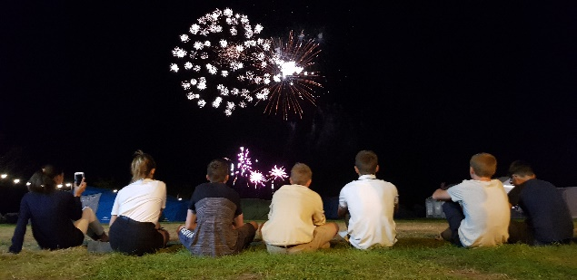
Youth group
WOW, what a term we had before the summer break- there is so much to catch you up with!
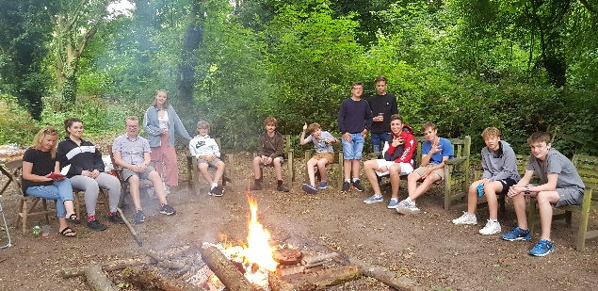
Taking advantage of the great weather we held an outdoor games evening, playing a game called Hunted; its a massive wide game which we played across the whole of Sevenoaks. At the end of July we held a BBQ at the Barnes’s house, which was a great way to finish off the term and say thank you and goodbye to Liz Coston for all the ways she has helped at youth group over the past few years.
As I’m sure you all know this year was the last ever Soul Survivor! It was in 2004 that I first came across the festival and attended as a teenager. The impact of Soul Survivor on me and my peers at the time was life changing and the full impact I think will never be fully known! It has been a joy taking our young people to S.S for the past 5 years and as they were for me, it’s been hugely influential in the faith lives our young people. This year was perhaps one of our best! We had an amazing week with too many highlights to write about, but with a group of around 30 of us we shared many moments of encountering God, many moments of joy and laughter and chances to serve in the cook tent! It was an emotional last night and was rounded off with a fantastic fireworks display that we gathered together to watch.
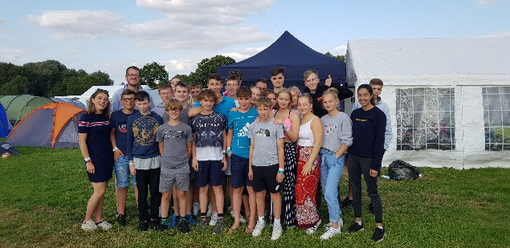
The festivals will be missed but it creates a space for something new to rise up in its place. I have a few vague plans up my sleeve for next year and will hopefully be able to announce something soon!
The youth had a great time running their own stall at the 250th Fun Day which was a huge success and this coming term we will be looking at the main Storylines that run through the Bible.
Children
In just a few weeks we will head off on our annual weekend away with the kids. “By the beach” is now fully booked and we have a full schedule of games, events and activities. We will be looking at 3 parables in our sessions with themes of lost, found, celebration and belonging. We have a great team of leaders coming and I’m super excited about our time away.
Schools
Our regular assembly slots in local schools continue as normal this term. Our contact with local schools is a vital part of our work in the community and a favourite aspect of my role. The regular clubs that I’m involved in have also got underway in the new term.

Students
We are blessed at BGBC to have a rapidly growing student group. We try and meet up when they are back during the holidays and a few weeks ago we held our student dinner hosted by John and Alison Riches.
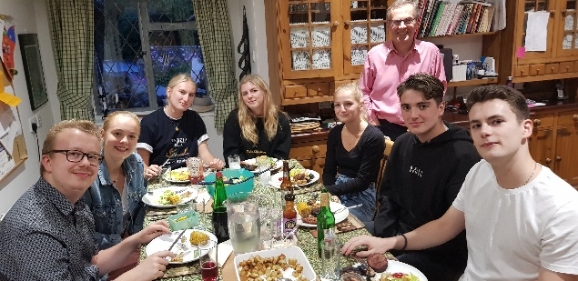
We have students all over the country and even in Europe too!
Short thought
About 4 years ago I stumbled across an author called Rachel Held-Evans. She had written a book called “Searching for Sunday”- it is to this day one of my favourite books. She went on to write “Inspired” (again another fantastic book). Can I take this chance to encourage you to read them. In May this year she tragically lost her life to what was at first a simple infection. She was a wife, mum of 2 young children and had so much more life to live. I sat on the sofa and cried for a good 30 minutes at this news. A few months on and I’m re-reading “Searching for Sunday”. This stood out to me and I wanted to share it with you:
“I was recently asked to explain to 3,000 youth workers gathered at a conference in Nashville why millennials like me are leaving the church. I told them we’re tired of the culture wars, tired of Christianity getting entangled with party politics and power. Millennials want to be known by what we’re for, not just what we’re against. We don’t want to choose between science and religion or between our intellectual integrity and our faith. Instead, we long for our churches to be safe places to doubt, to ask questions, and to tell the truth, even when it’s uncomfortable. We want to talk about the tough stuff-biblical interpretation, religious pluralism, sexuality, racial reconciliation and social justice-but without predetermined conclusions or simplistic answers. We want to bring our whole selves through the church doors, without leaving our hearts and minds behind, without wearing a mask.
I explained that when our gay, lesbian, bisexual and transgender friends aren’t welcome at table, then we don’t feel welcome either, and that not every young adult gets married or has children, so we need to stop building our churches around categories and start building them around people. And I told them that, contrary to popular belief, we can’t be won back with hipper worship bands, fancy coffee shops, or pastors who wear skinny jeans. We millennials have been advertised to our entire lives, so we can smell b.s from a mile away. The Church is the last place we want to be sold another product, the last place we want to be entertained.
Millennials aren’t looking for a hipper Christianity, we are looking for a truer Christianity, a more authentic Christianity. Like every generation before ours and every generation after, we’re looking for Jesus-the same Jesus who can be found in the same strange places he’s always been found: in bread, in wine, in baptism, in the world, in suffering, in community and among the least of these.
No coffee shops or fog machines required.”
So yep, this was aimed at an American audience and refers to millennials, but I also believe this to be true for Gen Z in the UK. After a number of conversations with young people over the summer I’m more convinced of this than ever. As I said during our Soul Survivor reflections, the thing that inspires me the most and fills me with hope for the future is our young people’s ability to include, look after each other and be real with one another about what’s going on for them.
Josh Amott- Youth and Children’s worker

