Youth and Children’s Newsletter January 2020
Wow, it’s amazing how much can happen and change in the space of a few short months! As I sit down to write this newsletter I am so grateful for the all the support and love that this Church has to offer.
Youth group
Leading up to Christmas our Wednesday group (UnBaja) were using a book and DVD resource called Story Lines from Soul Survivor. Each session looked at one of the main storylines running through the Bible, as well as our usual silly games which included me having to temporailiy ban a game called “DEATH CHAIR” due to health and safety concerns! We had a great term, finished off with a trip to Sevenoaks Panto.

We have a brilliant but rare moment at youth group right now; last term it was all boys and it looks like this is set to continue. Sometimes with youth groups you just have a natural gap like this. So this term, focusing our progarme around this, we will be reading a book together, the book is called “The man you’re made to be” by Martin Saunders, who co-leads Youthscpae. Its a brilliant book and I cant wait for the young people to get stuck into it.
Last term some of the older youth got together and did an escape room. Just before Christmas they went on a massive trip around Sevenoaks stopping at various houses to have a starter, main course and a pudding all organized by Corretta, Hans, Julian and Marina.
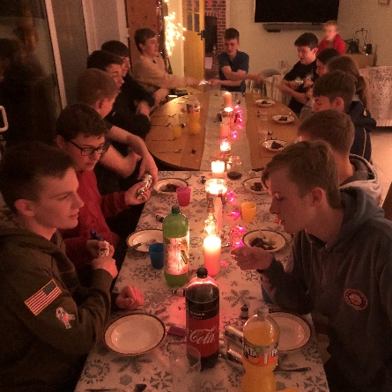

Children
As I write this on a Thursday morning there are currently around 100 people (adults and children) in the hall downstairs for Baby Plus. The noise and the organized chaos is all held together by the amazing team that run the group each week, headed up by Sarah Potter.
Our By the Beach trip in October was a huge success, we got up to all sorts including our traditional boat making activity, indoor rock climbing and looking at 3 different parables that Jesus told. At our end of year service a few weeks ago one child told me that By the Beach was the highlight of their year!
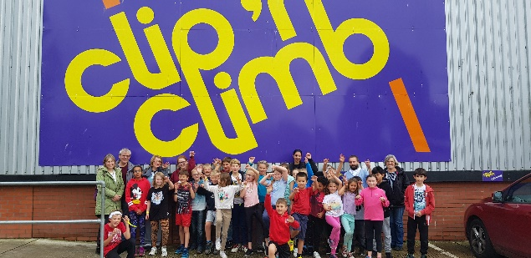
On Christmas Eve we held our children’s carol service. Myself and Anna Burrows led the charge and were delighted to see so many people from the community that we didn’t know.
Powerhouse continues to run alongside the Sunday morning service. As we see a growing number of children start to attend we are delighted to welcome two new leaders onto the team. Likewise the children’s work for the afternoon service continues to grow and the team continue to do an amazing faithful job.
Schools
In mid-December I had the privilege of driving the choir in the minibus from Dunton Green School to a local care home for them to sing carols together with the residents; it was a beautiful morning. All of our usual groups and assemblies continue for this coming term. Trinity will be holding a prayer space in school in early February which I have been asked to attend and help guide the students through.
Students
Please continue to pray for our students who have started back at Uni and College. This year our student group will continue to grow as more of our young people start to consider what the next step might be for them.
Prayer points
- Please pray for our new term at youth group as we start to read this book together. We pray that this will be a great chance to ask tough and exciting questions, chances for personal growth and deepening of friendships.
- For all our children’s groups and the amazing team who lead them. We pray that the children have an understanding in their own way of God’s love for them, so often shown through the team who teach and lead them.
- For our students who head back to Uni and College, may they know God’s guidance in their lives and that they have a Church back home who love them and stand behind them in prayer.

Short thought
This is an exercise we did at youth group a while ago and something I encourage our young people to do at the end of each day. It originates from Henri Nouwen’s work:
Questions to ask yourself at the end of the day-
- Did I offer peace today?
- Did I bring a smile to someone’s face?
- Did I say words of healing?
- Did I let go of anger and resentment?
- Did I forgive?
- Did I love?
I added a few questions of my own too
- Did I see the image of God in everyone?
- Did I act, think and speak humbly?
I have found this to be a really helpful exercise. It’s a very real way of examining our day and a very grounded way of living out our faith in our everyday lives.
What questions of your own would you add to this?
Josh Amott- Youth and Children’s worker

